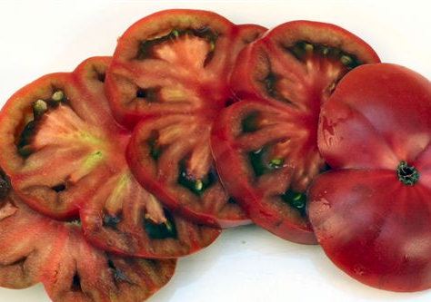
Differences between Hybrid & Heirloom Tomatoes
There are literally thousands of different varieties of tomatoes available for the home vegetable gardener today. With this huge assortment of tomato varieties comes a little confusion between what is a hybrid and what is a heirloom tomato. Here is some information on what is meant when someone says a tomato is a hybrid and when they say it’s an heirloom and what the differences between the two are.

Heirloom Tomatoes Although tomatoes are probably the most commonly referred to crop in the “heirloom versus hybrid” debate, nearly all vegetables have, or at one time had, heirloom varieties. A tomato is considered to be an heirloom when the seed has been saved and grown at least 50 years or more and has been passed down from generation to generation. An heirloom is also open-pollinated, which simply means the plant is capable of producing seeds that will grow a new plant identical to the parent plant the seed came from. Some examples of heirloom tomatoes are 'Black Krim', 'Cherokee Purple' and 'Brandywine'.
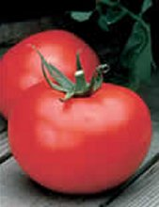
Hybrid Tomatoes Hybrid tomato varieties are generally produced by plant breeders. These plant breeders select two compatible tomato varieties and cross-breed them to create a new tomato variety that features traits from the two parent plants.
For instance, a plant breeder may select a particular tomato plant because of its resistance to blights, and another tomato that produces very early. The plant breeder cross-pollinates the two tomato plants to create a new variety. The new tomato variety now has the two traits from the parent plants – blight resistance and early production.
You will see many hybrid tomatoes labeled F1, which means it is a new tomato variety, or first generation. A tomato labeled F2 simply means it is the second generation of that tomato variety. Unlike heirlooms, seeds collected from a hybrid will not grow identical to the parent. It will grow with the traits of one of the parent plants, but not both. Many hybrid seeds are sterile and will not even germinate.
Some examples of hybrid tomato varieties are 'Better Boy', 'Early Girl' and 'Celebrity'.
GMOs Genetically modified crops (GM crops, or biotech crops) are plants used in agriculture, the DNA of which has been modified using genetic engineering techniques. In most cases the aim is to introduce a new trait to the plant which does not occur naturally in the species. Examples in food crops include resistance to certain pests, diseases, or environmental conditions, reduction of spoilage, or resistance to chemical treatments (e.g. resistance to a herbicide. The majority of the research and development has been focused on genetically altering plants to do one of two things:1. To produce their own internal pesticide to kill or deter insects; and 2, To remain alive when repeatedly sprayed with weed killers that are manufactured by these same corporations, including glyphosate (aka Roundup), glyfosinate, and 2-4,D (one of the primary ingredients of Agent Orange).

Source: http://www.veggiegardener.com/differences-between-hybrid-and-heirloom-tomatoes

